Before Execution -

Output 1C -

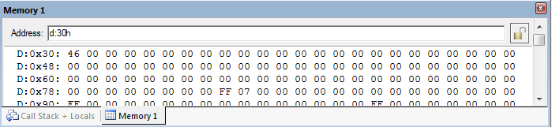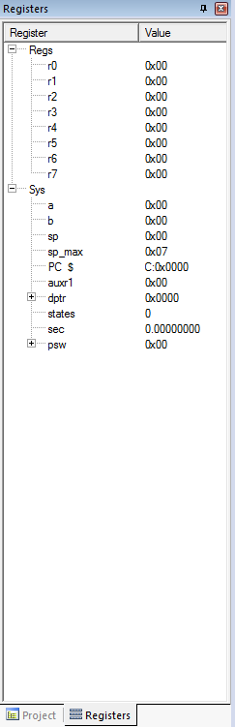

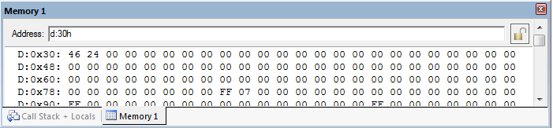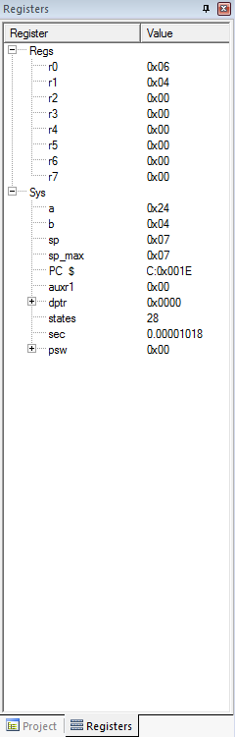

After Execution -